* Default sort order direction is ascending
* **HQL**

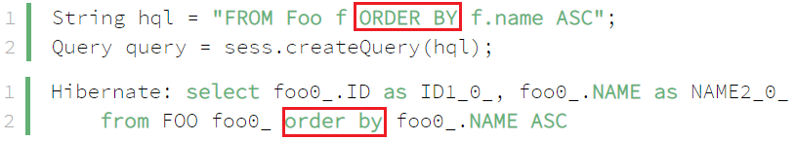

*Field*

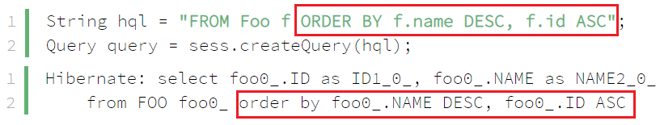

*Multiple field*

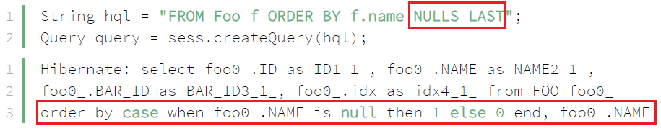

*Nulls FIRST or Nulls LAST*

* **Reference**

<https://www.baeldung.com/hibernate-sort>